
ALVIN ORINA-664724
ESTHER MUTUA-666620

SFE 4020A Group 2 Work/project
The Group work/ project consists of the design and implementation of the software architecture of a project of your choice. Implementation will take place using a tool of your choice.

Task 1
- In groups of 3-5 brainstorm on a webApp or a mobileApp that you can develop as a team.
- What area does your application Cover e.g. health, Finance, tourism etc.? Further explain why you chose that area for the application.
Education / Campus services (student administration and on-campus service queue management).
Why this area? Universities and colleges often have long physical queues for services (finance office, registrar, health center). A queue-management web app reduces waiting times, organises student flow, and is highly implementable as a group project (front-end + back-end + DB).

- Who are the intended users of the application?
Students (register, view queues, join a queue remotely)
Service staff / clerks (manage service counters, call next, mark served)
Administrators (view analytics, configure service slots, user management)

- What is the purpose of your application?
Let students see live queues for different offices and join remotely.
Let staff manage counters, call next student, and record service times.
Provide simple analytics (average wait times, busiest hours).
Reduce physical crowding, improve transparency.

- What are the benefits of the Application?
Shorter perceived waiting times (students can wait remotely).
Better staff workflow (organized queue, one-click call-next).
Data for admins to optimize staffing and hours.
Scalable: works on phones without app store installs.

- Which tools are you likely to use for your implementation and why? Do you have the skillset required? If not, what how do you plan to bridge the knowledge gap?
Frontend: React.js (Single Page Application) with Tailwind CSS.
Reason: React allows reusable UI components and supports an interactive user experience. Tailwind makes styling faster and consistent.
Backend: Node.js with Express.js.
Reason: Our application will require API calls and possibly real-time features. Node.js works well with asynchronous operations and integrates smoothly with React.
Database: MySQL.
Reason: Our group already has experience working with MySQL and it is suitable for handling structured data efficiently.
Version Control: Git and GitHub.
Reason: To allow collaborative development, track changes, and avoid code conflicts.
Deployment: Vercel for the frontend and Render/Heroku/XAMPP for backend depending on final deployment needs.
Our group already has skills in React, MySQL, and basic server-side programming. However, we have limited experience with Express.js, real-time communication (Socket.IO), and advanced backend APIs.
To bridge these gaps, we plan to:
- Assign team members based on strengths (frontend, backend, UX).
- Use short online courses/tutorials on Express, API development, and Socket.IO.
- Pair program on complex tasks such as authentication and deployment.
- Practice using documentation and community resources such as Stack Overflow and GitHub.

Task 2
2. Describe the organization of catalog along with the following design patterns as given by the gang of four (GoF).
a. Creational Patterns.
deal with object creation mechanisms, trying to create objects in a manner suitable to the situation (example,Factory Method, Prototype).
b. Structural Patterns.
focus on composition of classes/objects to form larger structures (example, Bridge, Decorator, Proxy).
c. Behavioral Patterns.
characterize communication between objects: how they interact and distribute responsibility (example, Command, Iterator, State, Template Method, Chain of Responsibility).
These patterns can be organized in a catalog where each entry contains:
- Pattern name
- Category (Creational/Structural/Behavioral)
- Problem addressed (short)
- Solution summary
- UML overview and sample code
- Typical uses / tradeoffs

3. Using a table show the classification of design patterns as introduced by the Gang of Four. The table should have the following subheadings.
Purpose | Design Patterns | Scope (Creational / Structural / Behavioral)
Create families of related or dependent objects without specifying concrete classes | Abstract Factory, Factory Method, Prototype, Singleton | Creational
Construct complex objects step-by-step | Builder | Creational
Compose objects to form larger structures; add responsibilities dynamically | Adapter, Bridge, Composite, Decorator, Facade, Flyweight, Proxy | Structural
Define object interaction and communication; algorithms and control flow | Strategy, Observer, Visitor, Command, Iterator, Mediator, State, Template Method, Chain of Responsibility | Behavioral

Task 3
4. for your chosen area of application, Design;
- Use cases
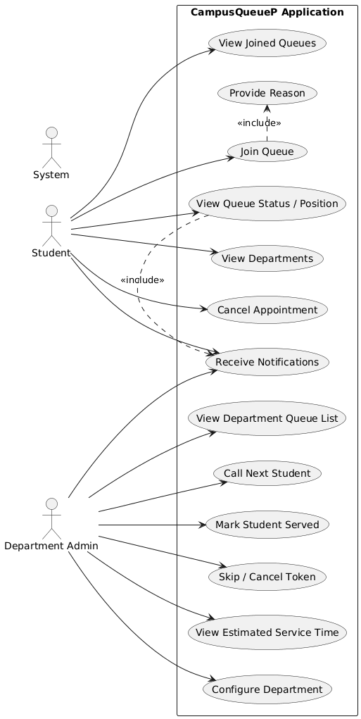
- Class Diagrams

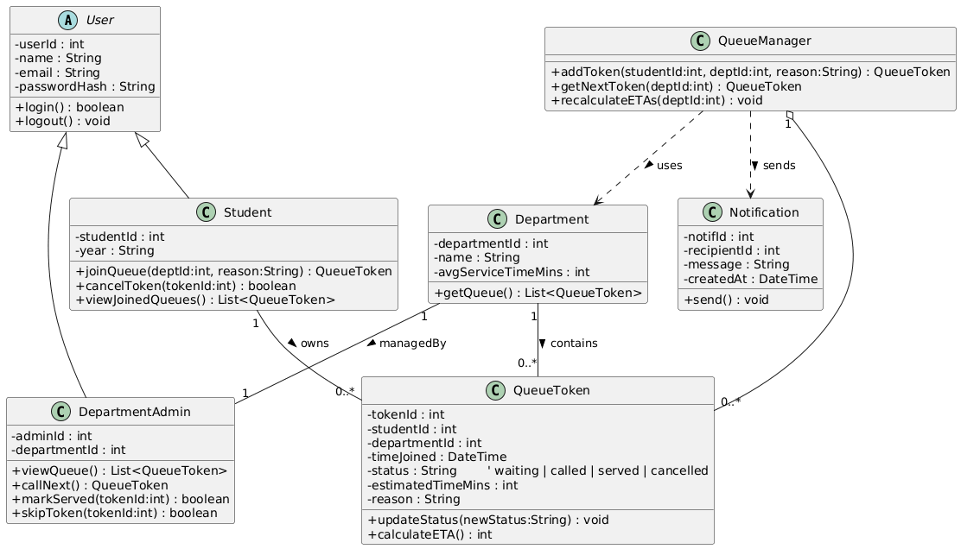
- Any other UML diagram of your choice.
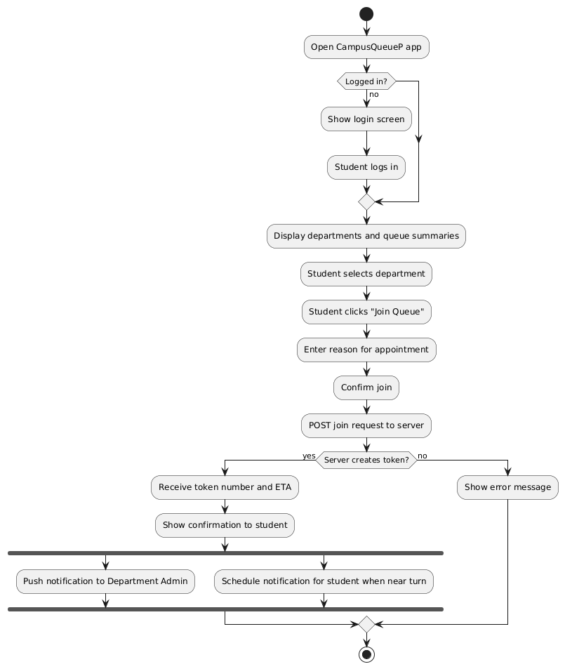
5. Design Patterns;
Using UML design;
- Abstract factory design pattern
- Adapter-class Design pattern
- Adapter-object Design pattern
- Strategy Design pattern
- Builder Design pattern
- Bridge Design pattern
- Decorator Design pattern
- Flyweight Design pattern
- Facade Design pattern
- Iterator Design pattern
- Mediator Design pattern
- Proxy Design pattern
- Visitor Design pattern
NB..chose any six. Do ensure that there is atleast one from each of the three major categories, i.e. Creational Patterns, Structural Patterns and Behavioral Patterns.
Category | Design Pattern | Purpose
Creational | Abstract Factory | Enables creation of department-specific queue objects without changing existing code.
Creational | Builder | Allows step-by-step creation of complex notifications in different formats.
Structural | Adapter (Object Adapter) | Makes external messaging services compatible with the system’s notification interface.
Structural | Facade | Simplifies access to multiple notification features through one unified interface.
Behavioral | Strategy | Allows switching between different queue management methods based on department needs.
Behavioral | Observer | Automatically updates and notifies students and admins when queue status changes.

Task 4
6. Implementation.
Using a tool of your choice write a program to implement each of the design pattern you choose in question 5 above.
I)Abstract Factory
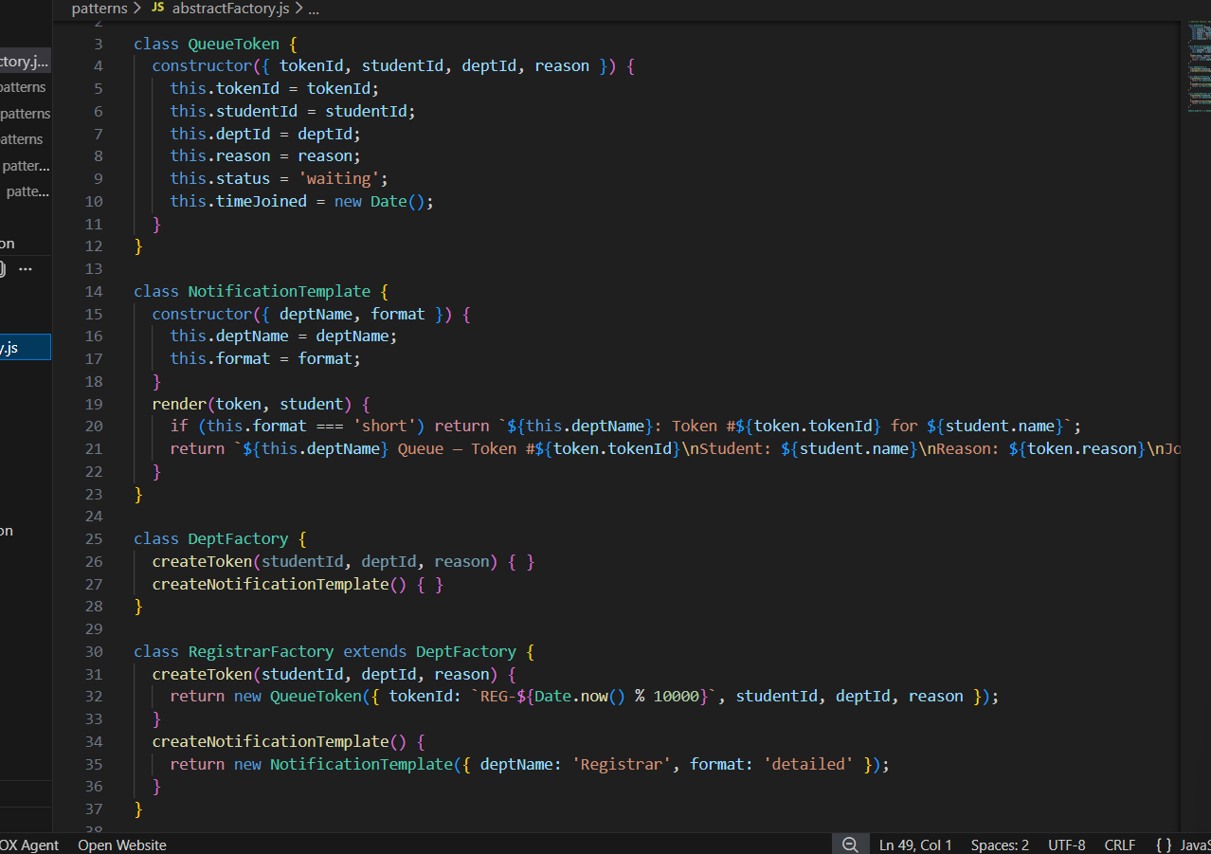
ii)Adapter
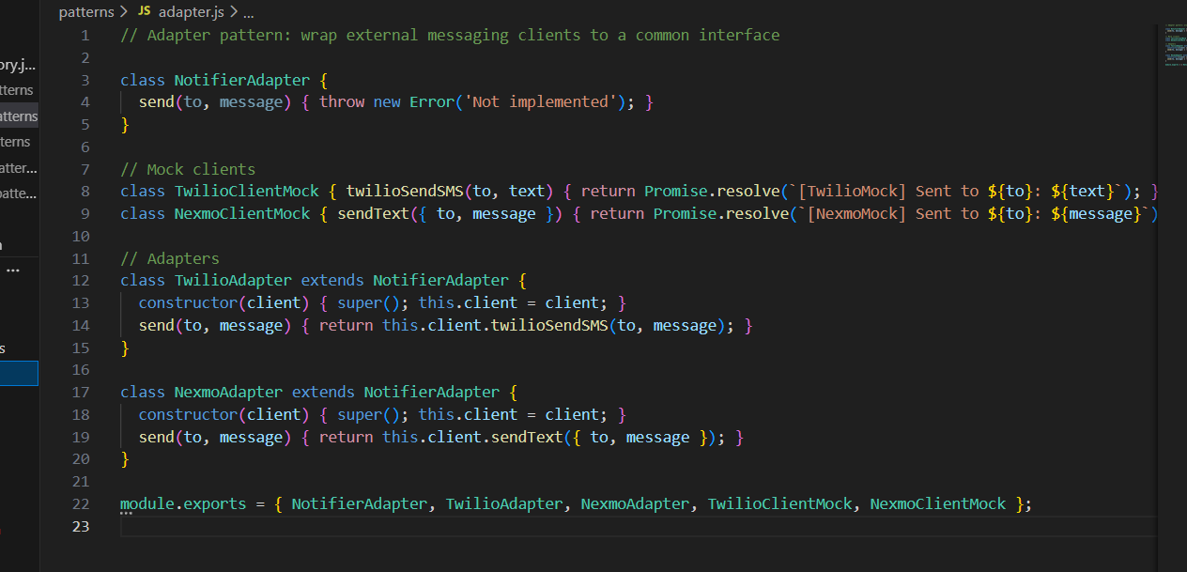
iii)Builder
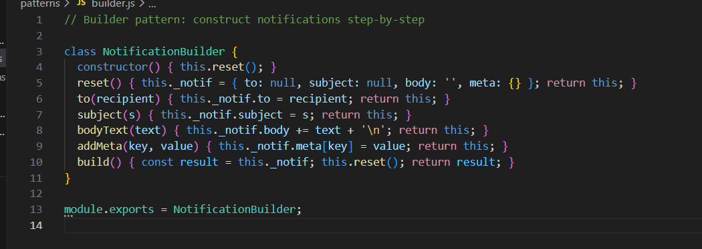
iv)Facade
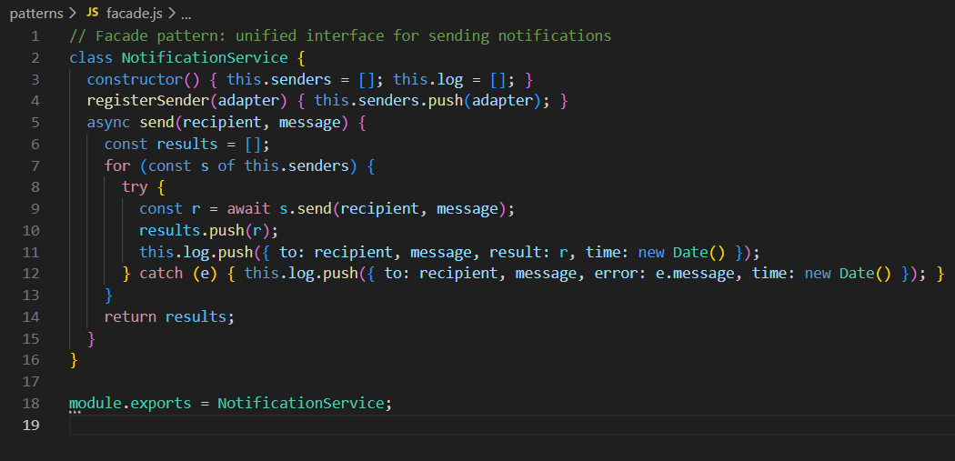
v)Observer
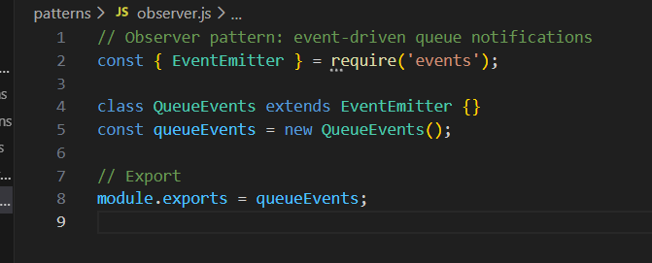
vi)Strategy
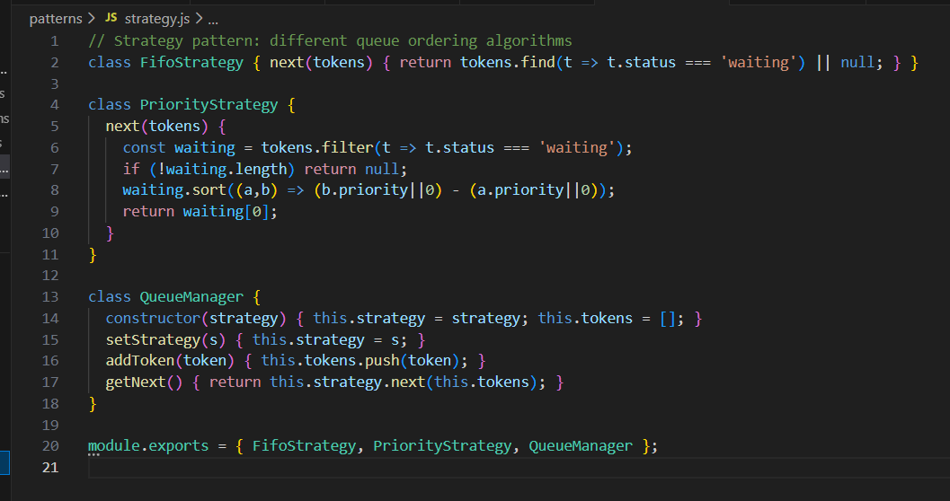
OUTPUT
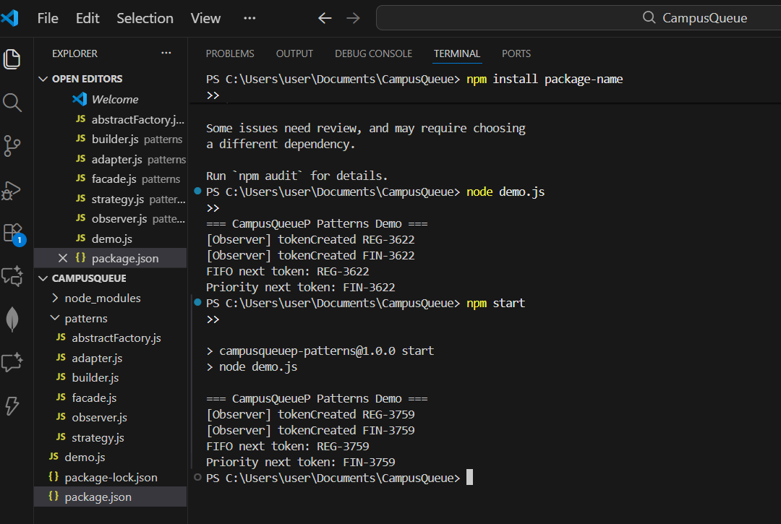
APPENDIX

